Thoughts about the psrccensus tool

1. On the home page your sent (https://psrc.github.io/psrccensus/index.html), the example install code line "devtools::install_github(“psrc/psrccensus”)" includes quotation marks that don't work in R - this isn't a huge issue, but does produce an error when copying/pasting into R – see below

1. The link at the bottom of this text (see above) redirects the user to this same page - I'm not sure if it's meant to bring the user to another page or if it hasn't been developed yet and the hyperlink is a placeholder for now?
2. On the ‘Getting Started’ page: think that the period between table.names and years is supposed to be a comma based on the code example shown below…

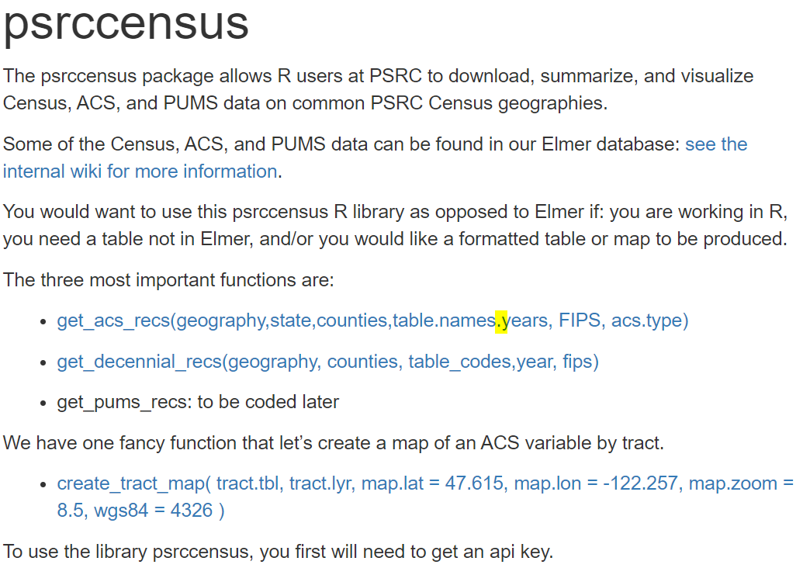

1. Block level data is apparently available for 5y table B25070 (GROSS RENT AS A PERCENTAGE OF HOUSEHOLD INCOME IN THE PAST 12 MONTHS - <http://aws-linux/mediawiki/index.php/Census-Year_2019_Summary_Datasets_in_Elmer>):

This doesn’t seem to be available through this tool? When I edited the geography to be 'block group' it didn't work. When I changed it to 'county' and to ‘tract’ it generated the tables that I was interested in.

* After trying different states, Washington is the only option that produces a populated tibble. Are there plans to include other states as an option for comparisons or national data as a reference?
* I was able to ask for Cowlitz County in the counties field counties=c(King County, Cowlitz County), but when I tried to ask for Cowlitz through the FIPS field FIPS=c(033, 015), it didn’t generate a table with Cowlitz County, but returned the other counties in PSRC? When I used FIPS=c(033, 053) to get Pierce, it still returned all of the PSRC counties.

1. get_acs_tract() and get_acs_place() return an error message using the code example on the Reference page

But they seem like they are supposed to generate similar results as the general get_acs_recs()?Should there be a difference in the outputs of the two functions shown below? Does something look wrong in the get_acs_tract() or get_acs_place() functions?

1. I followed the code to make a map and it worked well!

